­­­­­­­­­­­­­

**Regular Schedule:**

|  |  |  |
| --- | --- | --- |
| **Sunday:** | Bible Classes | 10:00 am |
|  | Assembly | 11:00 am |
|  | Assembly | 6:00 pm |
| **Wednesday:** | Bible Classes | 7:00 pm |

**Duty Roster**(01/22/17 –01/25/16):

|  |  |  |  |
| --- | --- | --- | --- |
| **Duties** | **Sunday A.M.** | **Sunday P.M.** | **Weds. P.M.** |
| Announcements | Manganello,J |  |  |
| Lead Singing | Mounts,J | McLellan,A | Gurtler,J |
| Read Bible | Shreve,N |  |  |
| Preside Table | Andrews,C | Wisdom,M |  |
| Serve Table | Wolfgong,J |  |  |
| Serve Table | Gurtler,J |  |  |
| Serve Table | Lee,L |  |  |
| Opening Prayer | Wisdom,M | McGibboney,G | Manganello,J |
| Closing Prayer | Shreve,S | Driedger,A |  |
| Preach or Weds. Invitation | O’Banion,P |  | Peguero,J |

|  |  |  |  |  |  |
| --- | --- | --- | --- | --- | --- |
|  | | | | | |
| **Prayer Requests**   * Remember the new, on-going, and general prayer requests on Joe’s  prayer list. * Remember those mentioned during Wednesday and Sunday assemblies**.**   **WHAT MUST I DO TO BE SAVED?** | | | | |
| 1. Hear the Gospel | (Acts 15:7) | 1. Believe in Jesus | (Acts 8:12) |
| 1. Repent of My Sins | (Acts 3:19) | 1. Confess Jesus | (Acts 8:37) |
| 1. Be Baptized in Water | (Acts 22:16) | 1. Remain Faithful | (Acts 2:42) |

­­­­­ Sunday January 22, 2017

**The Exton Exhorter**

WELCOME TO OUR VISITORS!

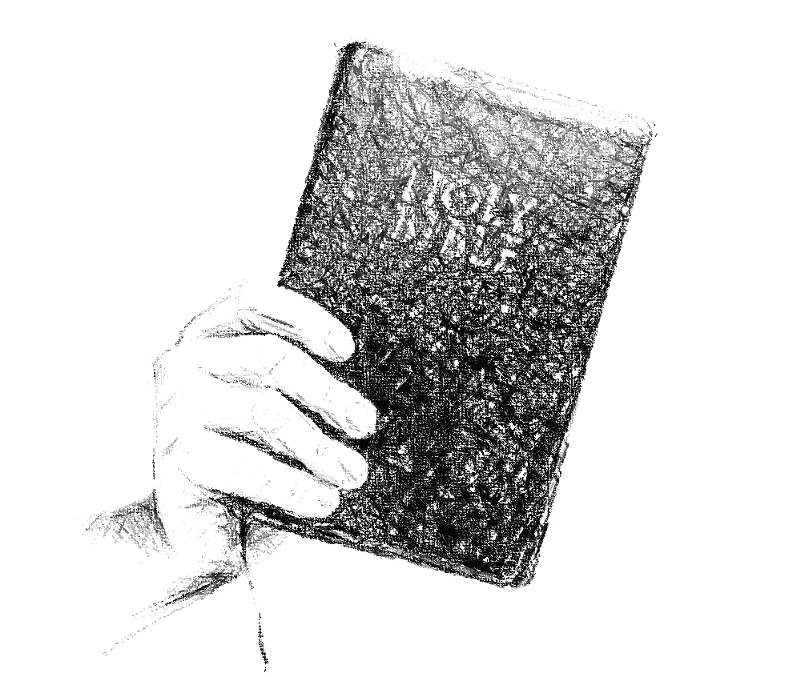

***Exton***

**CHURCH OF CHRIST**

217 North Whitford Road

Exton, PA 19341

**Phone**: 1-610-363- 8042

**Email**: [extonpachurch@gmail.com](mailto:extonpachurch@gmail.com)

**Website**: [www.extonchurch.org](http://www.extonchurch.org)

“Offer right sacrifices,  
     and put your trust in the Lord.”

Psalms 4:5 ESV **Volume 2, Issue 29**

Their gatherings were reverent and orderly (1 Corinthians 14:40), characterized by songs and prayer (1 Corinthians 14:15), and instruction in God’s word (1 Corinthians 14:6, 26, Acts 20:7).

In the New Testament descriptions of churches, notice the things we don’t see: denominational identity, man-made doctrines, emphasis on grandeur, or emphasis on entertainment. Instead, in each church we see a simple organization of people simply serving God in accordance with the instructions being given through the Apostles that Jesus sent out into the world.

Those instructions have been preserved for us today in the Bible. If you visit one of our assemblies, you will find us aiming to follow those same instructions.

By Jeff Smelser

**What the Church at Exton Aspires To Be**

In the time of the New Testament, as the gospel was preached from city to city, hearers became believers and were baptized into Christ. In each locale where this happened, these people, now disciples of Christ, began assembling together to commemorate Jesus’ death (Acts 20:7, 1 Corinthians 11:23-34), to edify one another (1 Corinthians 14:26), and to worship God. They regularly came together on the first day after the Sabbath, or as many English translations say, “the first day of the week” (Acts 20:7, 1 Corinthians 16:1-2), this being the day on which Jesus had been raised from the dead. We know the day after the Sabbath as “Sunday.” In the book of Revelation, John called it “the Lord’s Day.”

These gatherings were not merely ad hoc events. Just as politically, residents of a particular area might form a town and have town meetings, the disciples in each locale understood that spiritually, they together formed an assembly of God’s people, or as many English translations read, a church. Older men in each assembly, or church, were appointed as spiritual overseers, metaphorically known as shepherds (Acts 14:23, 20:28, Titus 1:5, 1 Peter 5:1-3). They appointed others referred to as servants (some English translations use the word “deacons”; Philippians 1:1, 1 Timothy 3:8-13) who  were to see that necessary works were accomplished which might include such things as seeing to the needs of widows among the group (Acts 6:1-6).

In each church, the disciples encouraged one another to love and good works (Hebrews 10:24-25). They held one another accountable for obedience to the word of God (Galatians 6:1, 2 Thessalonians 3:6-15, 1 Corinthians 5:1-13). They assisted the needy (1 Corinthians 16:1-4, Romans 15:25-26) and funded the efforts of men who were preaching the gospel even in remote locations (Philippians 4:15-17).