­­­­­­­­­­­­­

**Regular Schedule:**

|  |  |  |
| --- | --- | --- |
| **Sunday:** | Bible Classes | 10:00 am |
|  | Assembly | 11:00 am |
|  | Assembly | 6:00 pm |
| **Wednesday:** | Bible Classes | 7:00 pm |

**Duty Roster**(10/30/16 – 10/02/16):

|  |  |  |  |  |  |  |
| --- | --- | --- | --- | --- | --- | --- |
| **Duties** | | **Sunday A.M.** | | **Sunday P.M.** | **Weds. P.M.** | |
| Announcements | | Shreve,S | |  |  | |
| Lead Singing | | O’banion | | Lewis,M | Wolfgong,J | |
| Read Bible | | Richerdson,B | |  |  | |
| Preside Table | | Mounts,J | | Wisdom,M |  | |
| Serve Table | | Mueller,J | |  |  | |
| Serve Table | | Shreve,N | |  |  | |
| Serve Table | | Andrews,N | |  |  | |
| Opening Prayer | | Wolfgong,J | | Robey,V |  | |
| Closing Prayer | | Mcgibboney,G | | Shreve,R | Lewis,M | |
| Preach or Weds. Invitation | | Andrews,C | | Mclellan,A | Shreve,N | |
| |  | | --- | | **Bible Classes** |  * The Wednesday 7pm adult bible class is studying Kings of the Old Testament. * The Sunday 10am adult bible class is in the New Testament for the  “Read Through the Bible in A Year” series. | | | | | | | | | |
| **Prayer Requests**   * Remember the new, on-going, and general prayer requests on Joe’s  prayer list. * Remember those mentioned during Wednesday and Sunday assemblies**.**   **WHAT MUST I DO TO BE SAVED?** | | | | | | | | |
| 1. Hear the Gospel | (Acts 15:7) | | 1. Believe in Jesus | | | (Acts 8:12) | |
| 1. Repent of My Sins | (Acts 3:19) | | 1. Confess Jesus | | | (Acts 8:37) | |
| 1. Be Baptized in Water | (Acts 22:16) | | 1. Remain Faithful | | | (Acts 2:42) | |

­­­­­ Sunday 30, 2016

**The Exton Exhorter**

WELCOME TO OUR VISITORS!

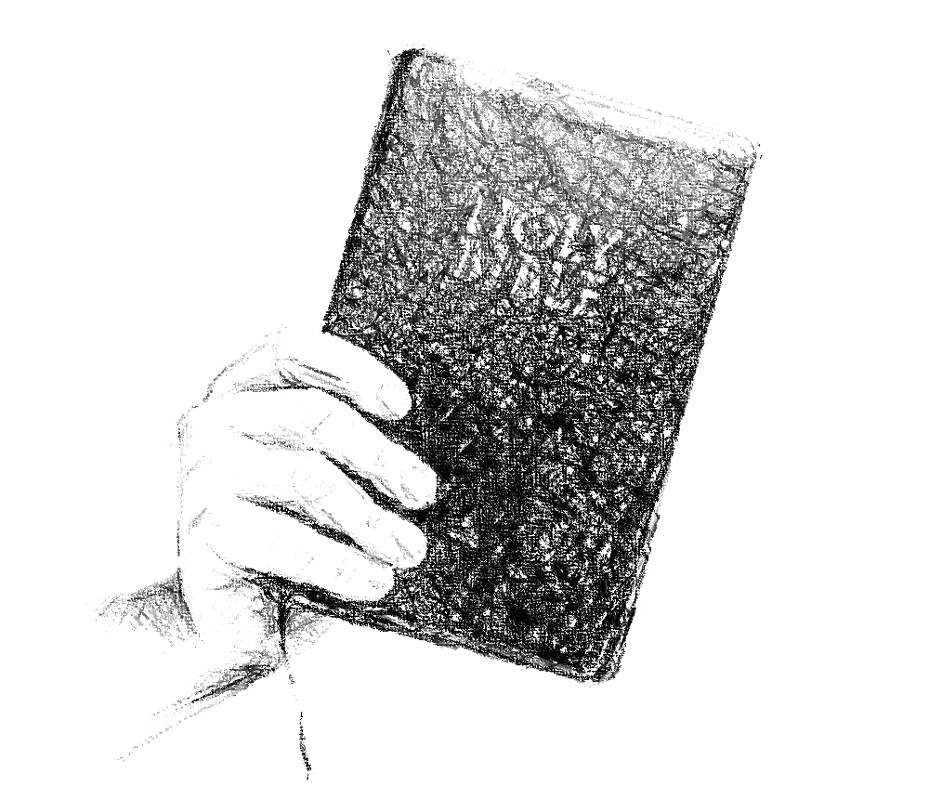

***Exton***

**CHURCH OF CHRIST**

217 North Whitford Road

Exton, PA 19341

**Phone**: 1-610-363- 8042

**Email**: [extonpachurch@gmail.com](mailto:extonpachurch@gmail.com)

**Website**: [www.extonchurch.org](http://www.extonchurch.org)

Whoever mocks the poor insults his Maker;  
    he who is glad at calamity will not go unpunished.

Proverbs 17:5 (ESV)

**Volume 2, Issue 23**

Men have two options: 1) we can continue sinning whereby we follow the devil as our father 1John 3:8-10) and make sin our master (Rom. 6:16);2) we can turn our hearts to God according to the gospel and have Him as our Father (Gal. 3:26) and righteous as our master (Rom. 6:18). One thing we can be certain of is that we cannot live in sin and claim God as our Father! (1 John 1:6; 2:4) Therefore, true gospel preaching acknowledges that repentance is just vital to our salvation as faith itself.

Will you repent, turn to God and do works befitting repentance?

By DP

From Bulletin of the Birchwood Avenue Church of Christ

Repentance

Repentance is a theme stressed often in the Scriptures, but often avoided by many religious teachers today. Interestingly, the first words recorded concerning the preaching of the kingdom in the New Testament were, “Repent for the king of heaven is at hand” (Matthew 3:2; 4:17; Mark 1:15). This theme was emphasized by both John the Baptizer and Jesus Christ.

Luke records Jesus after His resurrection as saying, “Thus it is written, and thus it was necessary for the Christ to suffer and to rise from the dead the third day, and that repentance and remission of sins should be preached in His name to all nations, beginning at Jerusalem”(Luke 24:46-47). In fulfillment of this, Peter commanded the Jews on Pentecost, saying, “Repent, and let every one of you be baptized in the name of Jesus Christ...” (Acts 2:38). This same theme is carried through to the end of the New Testament (Rev. 3:19).

What all of these passages teach us is that God is looking for people who are willing to humble themselves and to approach Him with penitent hearts, as David did in Psalm 51:17, saying, “The sacrifices of God are a broken spirit, a broken and a contrite heart—These, O God, You will not despise.”Sadly, however, the meaning of true repentance Therefore, we would do well to consider repentance such as God desires of those who would come to Him for the forgiveness of their sins.

The word “repent” literally means to turn 180º; to change one’s mind. Therefore, according to Acts 26:20, Paul preached to all men “that they should repent, turn to God, and do works befitting repentance.” Before repentance, one’s life is filled with sin and his desire is to fulfill

his own will and to walk by some worldly standard which is contrary to God. But in repentance one changes his mind by turning away from sin and the world and turning toward God This is the 180ºturn. In order for a person to repent he must change his heart from seeking his own will to seeking God’s will. This involves a decision, but more so a commitment of the will

Through the gospel of Jesus Christ God makes it possible for us to turn to Him Jesus provides the knowledge of the truth so that we may know

God and His will (John 1:17, 18; Eph. 4:21). Therefore the apostle Paul.

preached the gospel, saying, “Truly, these times of ignorance God overlooked, but now commands all men everywhere to repent” (Acts 17:30).